# **Quest 3 Development Guide**

**Quest 3 Development Guide 1**

**Enable Developer Mode 2**

**Setting up Headset for AR development in Unreal Engine 5 5**

**Enabling Quest Link for VR previews in UE5 6**

**Getting started with VR/AR development in UE5 8**

**Android Studio Setup 8**

**Passthrough Setup (UE 5.3) 9**

**Packaging UE5 Project into APK for Headset 11**

**Casting headset POV to another screen 12**

**Unreal Engine 5 Development Notes 13**

# Enable Developer Mode

**Register Meta profile as a developer account - DO THIS FIRST**

Log in to your Meta account. Make sure it is the same account as on your headset.

Click on “My Apps” at the top row.

Verify your Oculus developer account. Choose one of the following methods.

* Add your credit card.
* Set up Two-Factor Authentication (Preferred method)

On the headset, go to **Settings >** **System >** **Developer** and enable custom settings

Download the Meta Quest app on your mobile device and log into your developer meta account. Locate the device you linked during set up. Navigate to headset settings and **enable USB debugging mode**. Connect your headset to the computer using a USB-C cable and wear the headset. Accept Allow USB Debugging and Always allow from this computer when prompted on the headset.

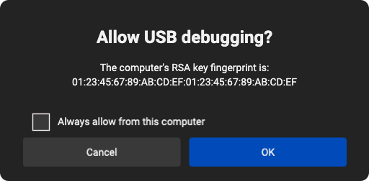

[Device Setup | Oculus Developers](https://developer.oculus.com/documentation/native/android/mobile-device-setup/)

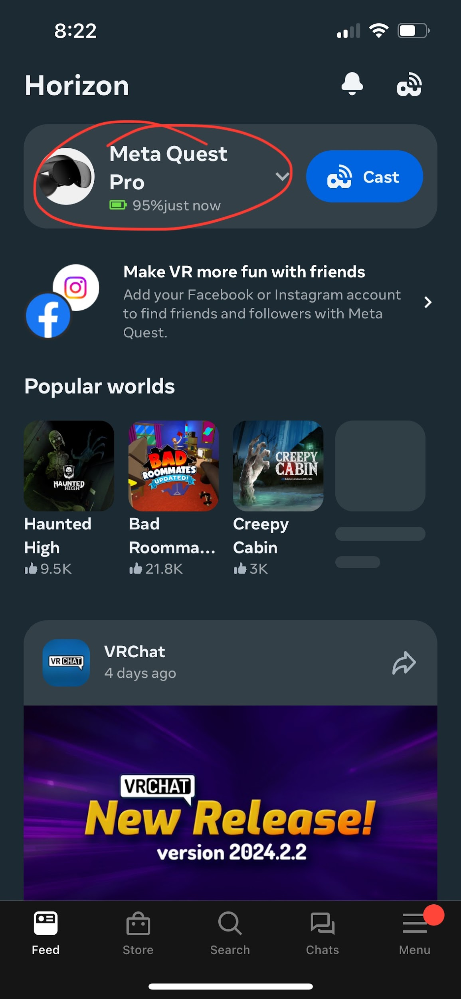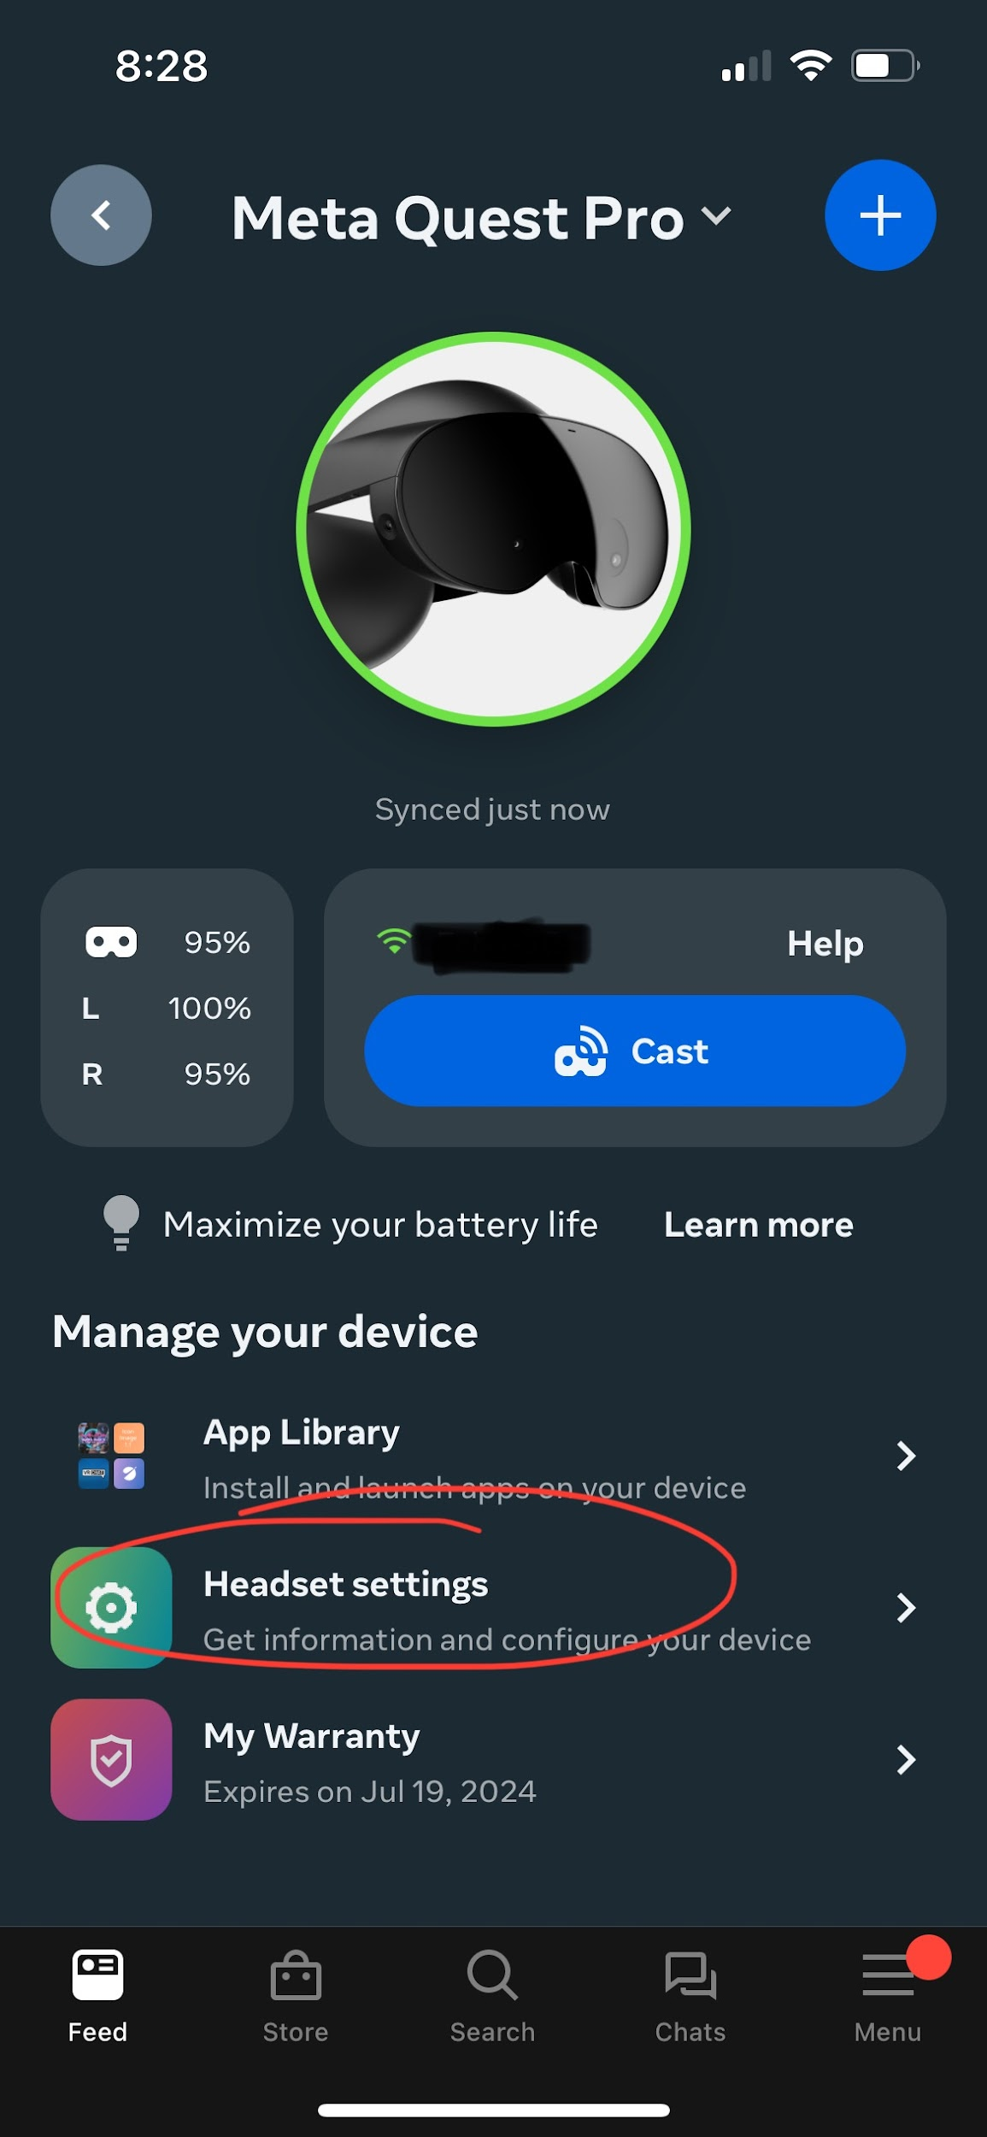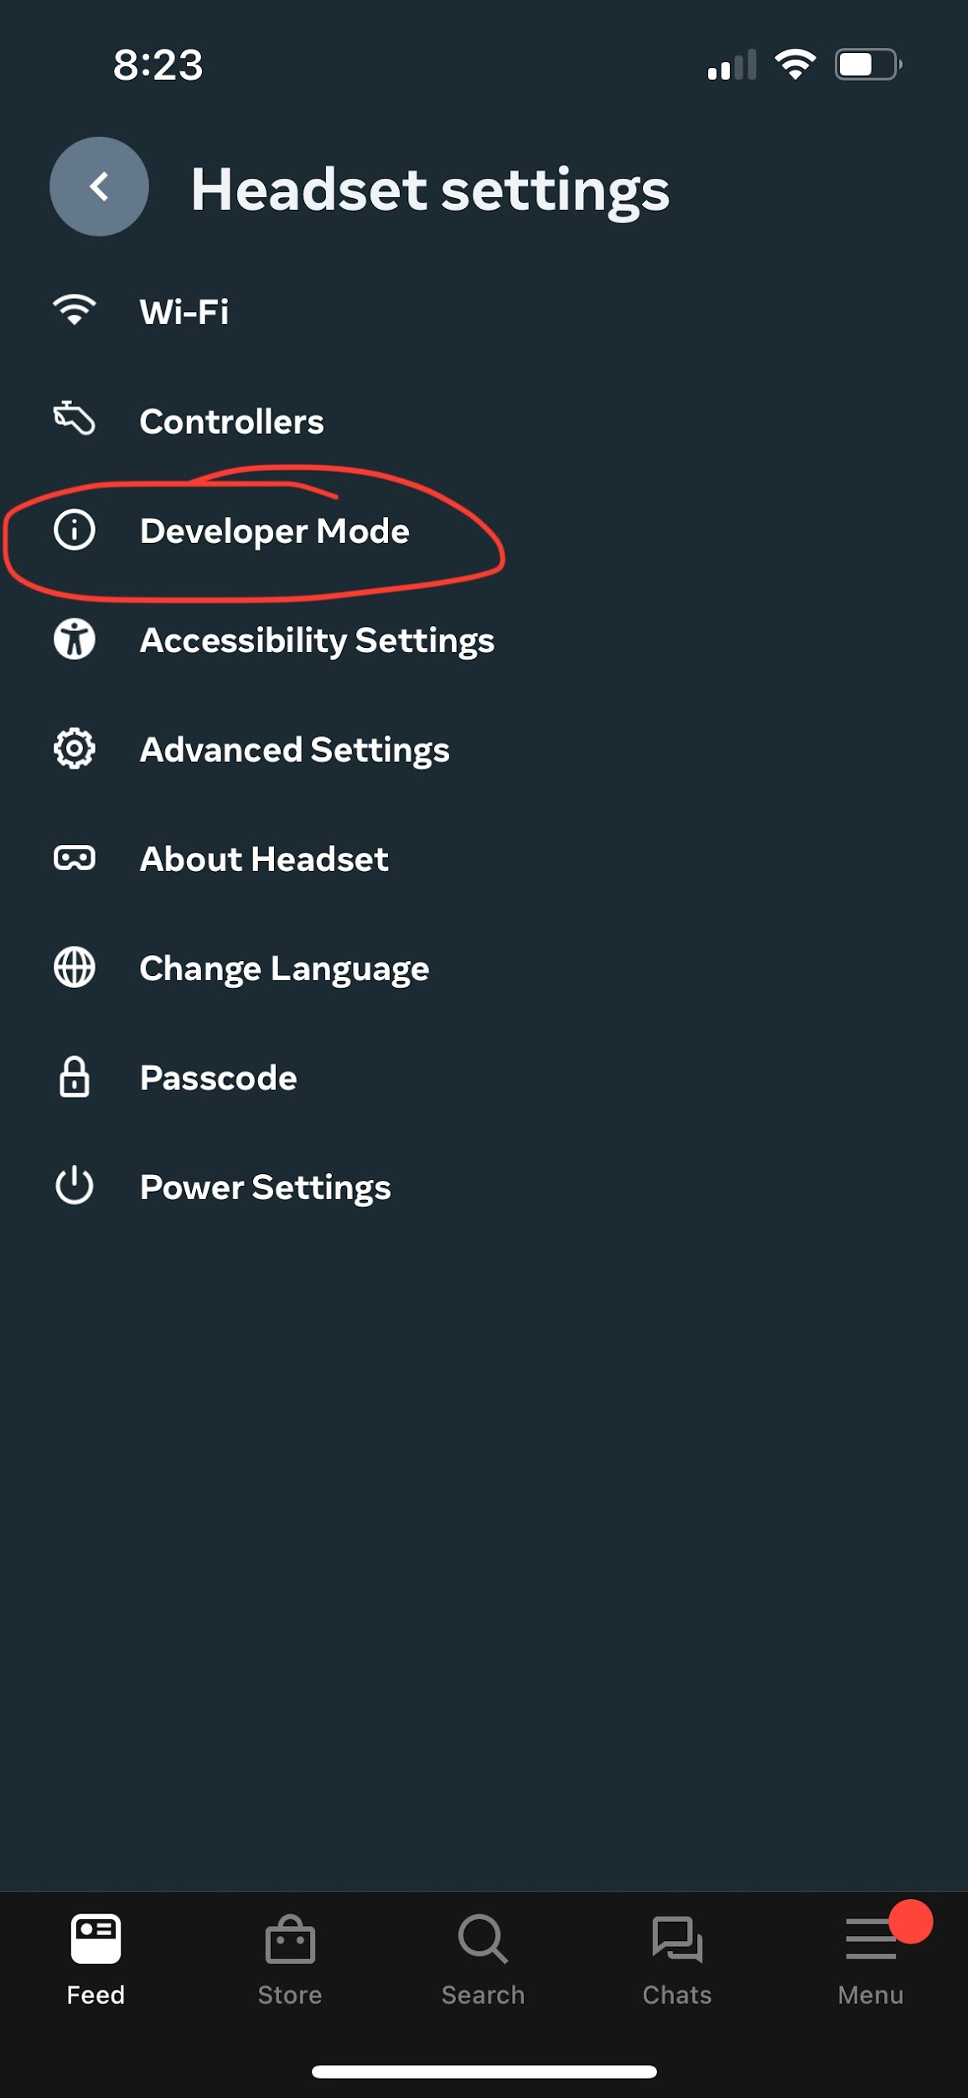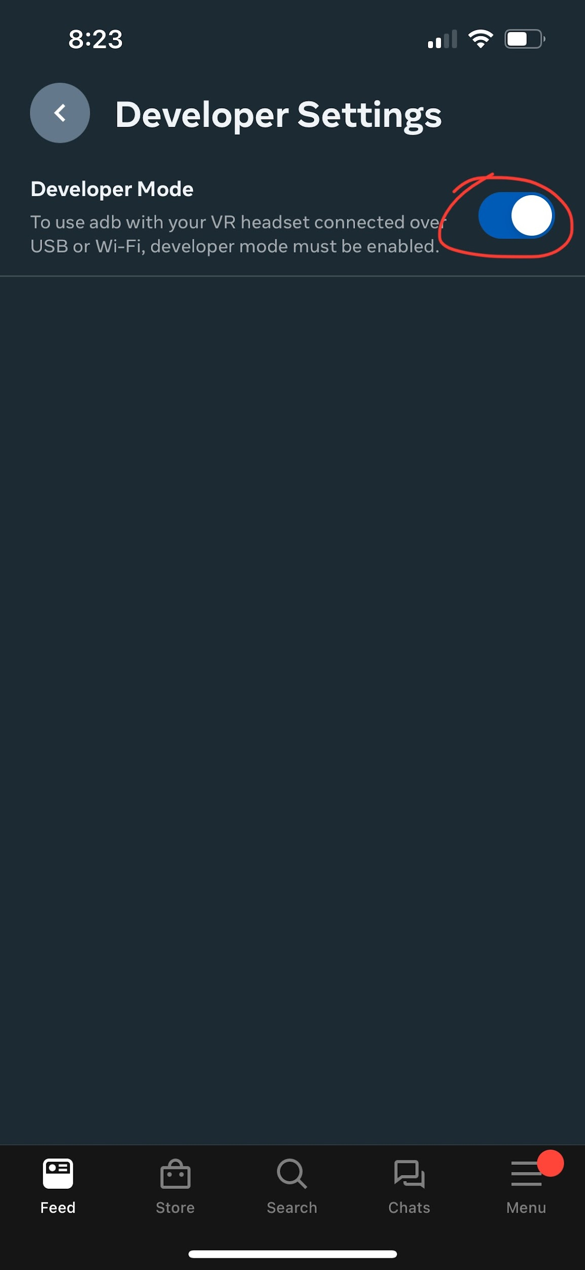

# 

# Setting up Headset for AR development in Unreal Engine 5

<https://www.meta.com/quest/setup/>

Download the Meta Quest mobile app on your smartphone, create a Meta account if necessary, then wirelessly connect your headset and mobile to complete the setup process Meta provides. (Headset must be connected to the same wifi as your mobile device)

You will then need to download the Oculus app on a capable PC and login on the app as well. To run Unreal projects on the headset you need to follow the following steps:

* Go to **Settings >** **General** andenable the “Unknown Sources” toggle. Then, be sure to click “Set Oculus as active” under “OpenXR Runtime.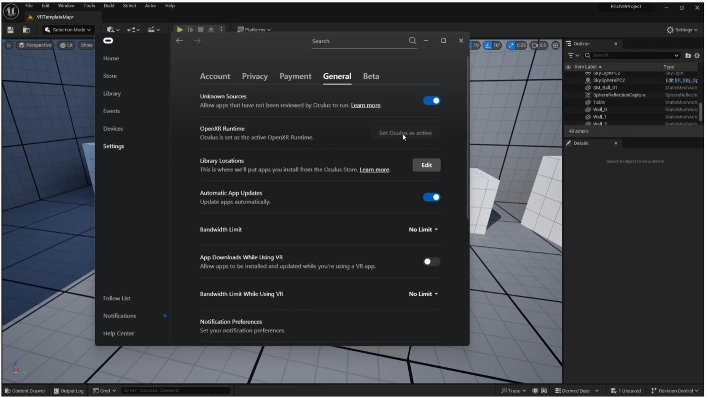

# Enabling Quest Link for VR previews in UE5

Connect the headset to a computer either through Air Link (Wireless) or Link Cable (USB). Link Cable will likely be the optimal choice as the wireless connection can be unstable or simply not provide enough bandwidth for an enjoyable experience. It is also heavily recommended to use an official Oculus Link Cable for the best experience, some USB cables may not be able to provide enough bandwidth.

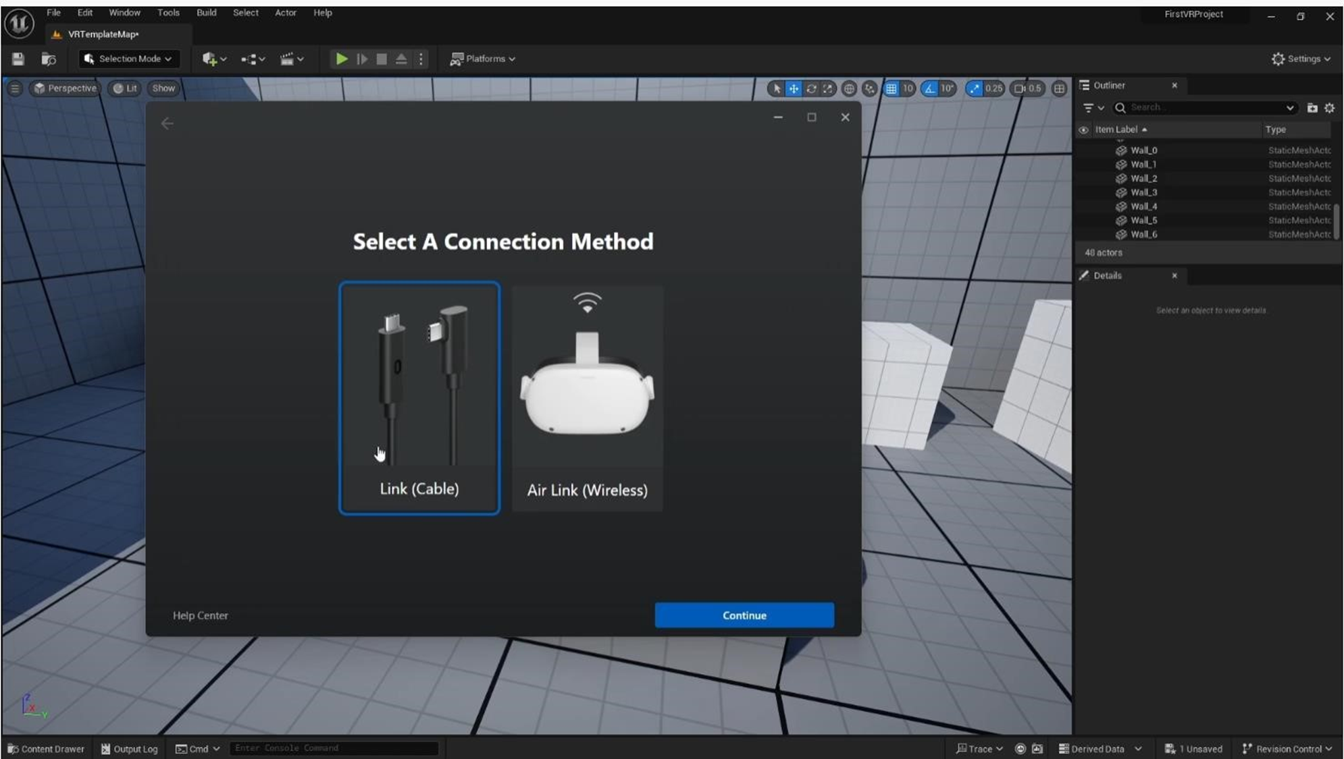

Put the headset on after it is connected to the PC. A popup will show up asking if you want to enable Quest Link. Press “Enable”. If it doesn’t go to the quick menu by clicking on the time in the bottom left corner, and find “Quest Link” in the menu.

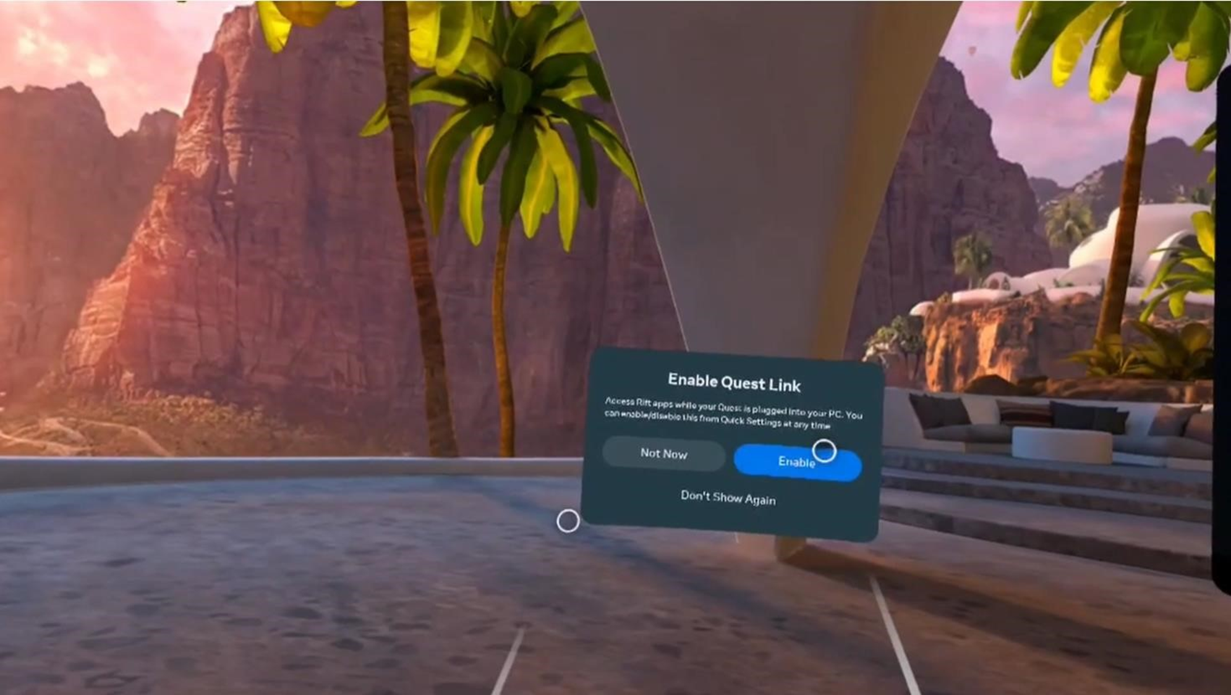

The below image is what you will see when you start Quest Link.

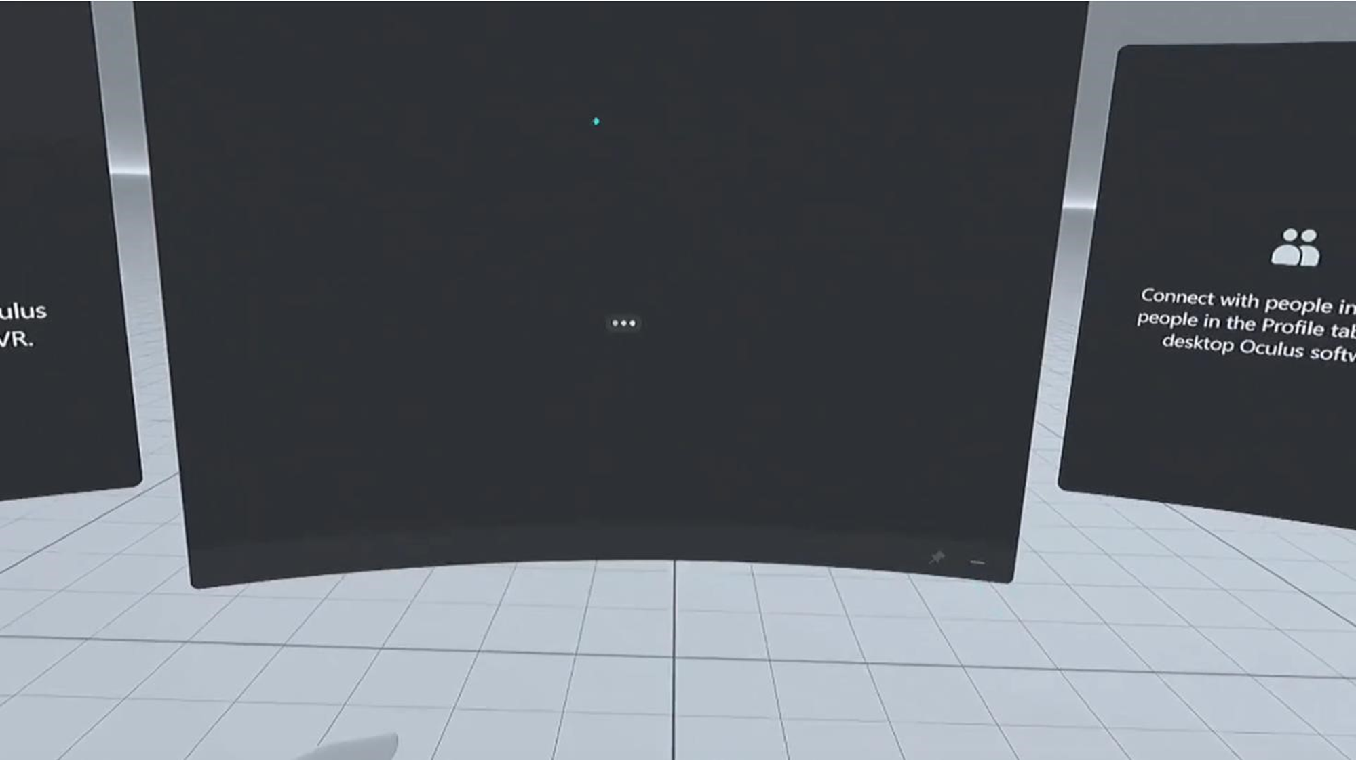

# Getting started with VR/AR development in UE5

* VR template
* Installing the Meta XR plugin
  1. Download the Meta XR plugin from the following page: <https://developer.oculus.com/downloads/package/unreal-engine-5-integration/>
  2. Extract the contents of the .zip file to the Unreal Engine Marketplace folder, it will have a path similar to this based on where Unreal Engine is installed on your PC:  
     **C:\Program Files\Epic Games\UE_5.0\Engine\Plugins\Marketplace**
     + Make a folder called Marketplace if none exists (capitalize M, it is case-sensitive)
* New empty level Motion controller for each hand
* Oculus passthrough layer

# Android Studio Setup

Video to follow: <https://www.youtube.com/watch?v=CRDDgFKuPh8>

Navigate to <https://developer.android.com/studio/archive>

Scroll down and install Android Studio 4.0 from May 28, 2020 (**MUST BE THIS VERSION**)

Run installer (Remember SDK and NDK file paths for later)

Once Android Studio is installed click **Configure**

Click the tab for SDK tools, and scroll down until you see **Android SDK Command Line tools 8.** Check the box and install

Navigate to the Unreal Engine folder, then go to **Engine > Extras > Android**

Locate SetupAndroid.bat

Find the line that sets the studio SDK path and change it from latest to 8.0 (the CMD version we just installed).

Double click the SetupAndroid.bat to run it

Navigate to windows environment variables and check that Unreal set the proper path

for **ANDROID_HOME, NDKROOT**

You may need to also install Java JDK 17.0.9 from here - <https://www.oracle.com/java/technologies/javase/jdk17-archive-downloads.html>

Settings to build to the Quest 3 can be found under **Packaging UE5 Project into APK for Headset**

# Passthrough Setup (UE 5.3)

This video is pretty good, but it is also detailed below.

<https://www.youtube.com/watch?v=8bNBgoL6TGA>

1. Have Meta XR Setup already!
2. Create a new VR template project.
3. Go to **Edit > Plugins > Virtual Reality** and enable Meta XR. Restart the project.
4. Go to **Edit > Project Settings > Rendering**. Set “Enable alpha channel support in post processing (experimental)” to “Allow through tonemapper.” Also set “Anti-Aliasing Method” to “Multisample Anti-Aliasing (MSAA).”
   1. Important Note: You do not need to restart everytime you change a setting. Restart later in the instructions after all of the settings are correct.
5. Go to **Edit > Project Settings > Meta XR** and check the boxes next to “Passthrough Enabled,” “Anchor Support,” “Anchor Sharing,” and “Scene Support.” Also check “Support Experimental Features” near the bottom of the list.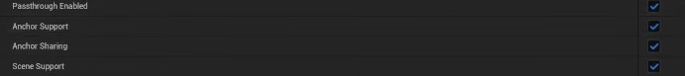
6. Click “add element” next to “Supported Meta Quest Devices” 3 times, until it appears as below.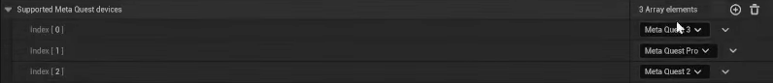
7. Restart the project to enable the changes we just made.
8. In the Content Manager, go to **VRTemplate > Blueprints** and open VRPawn.
9. Select the camera component and add the “Oculus XRPassthrough Layer” component.

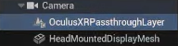

1. Under the “Oculus XRPassthrough Layer” component, enable “Supports Depth,” “No Alpha Channel,” and set “Stereo Layer Shape” to “Reconstructed Passthrough Layer.” Click the dropdown under “Stereo Layer Shape” and set “Layer Placement” to “Underlay.”
2. Compile VRPawn.
3. Ensure that under **Settings > Engine Scalability Settings** that “Effects” is set to “Epic.”
4. Delete objects in the scene so that the unreal engine editor shows a black void.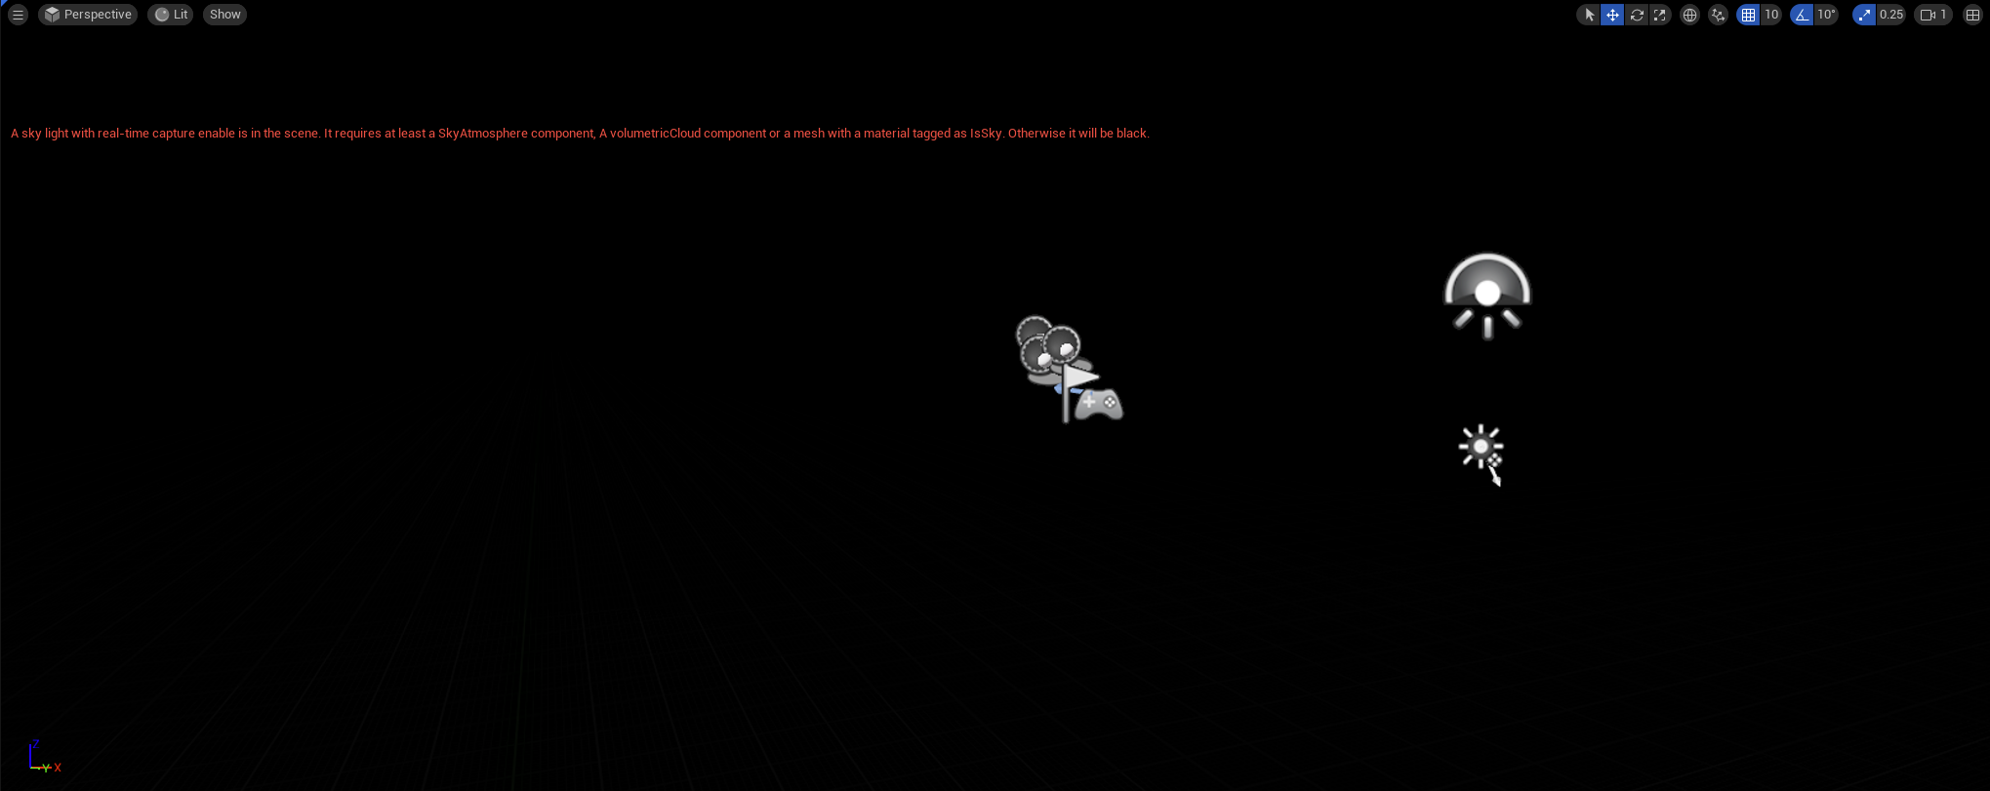
5. Run the app in “VR Preview.”   
   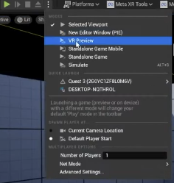
   1. If this option is blocked, then the headset is not in Quest Link mode yet. Restart the project with quest link activated.
6. Passthrough does not appear in the normal unreal engine preview. To view the passthrough on a computer, go to the link below and cast the headset to your internet browser. More information in the “Casting headset POV” section.

<https://www.oculus.com/casting>

# Packaging UE5 Project into APK for Headset

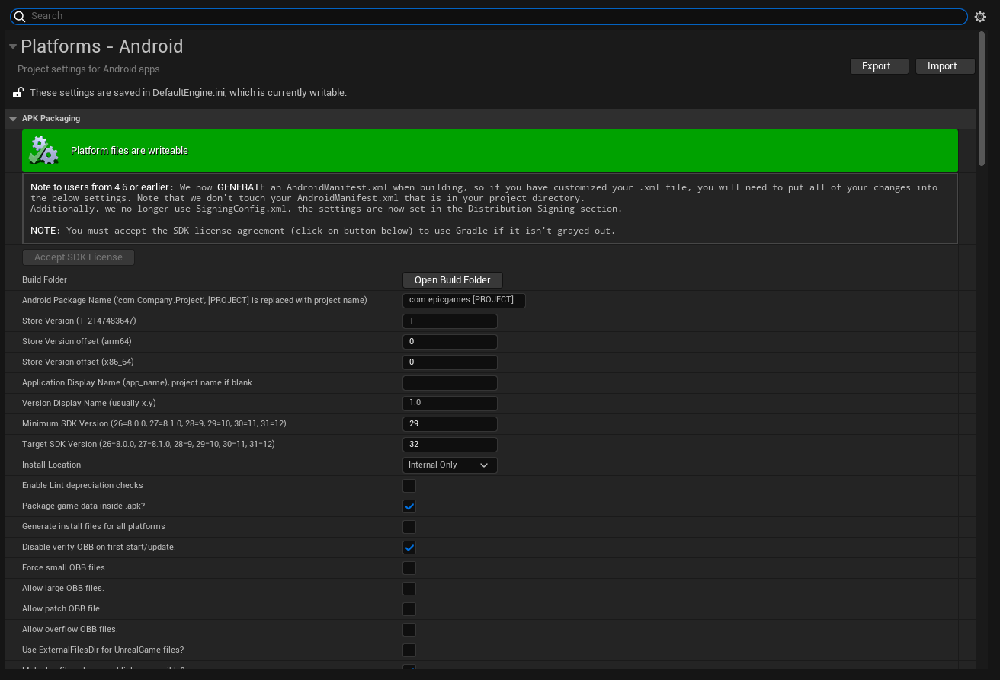

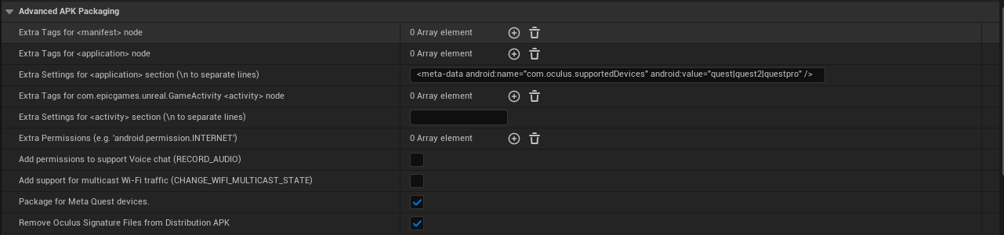

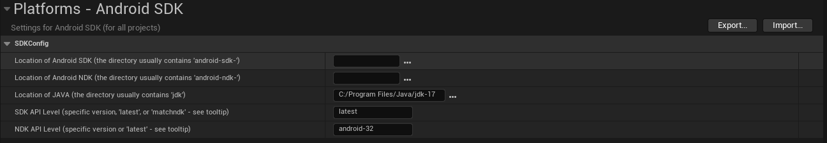

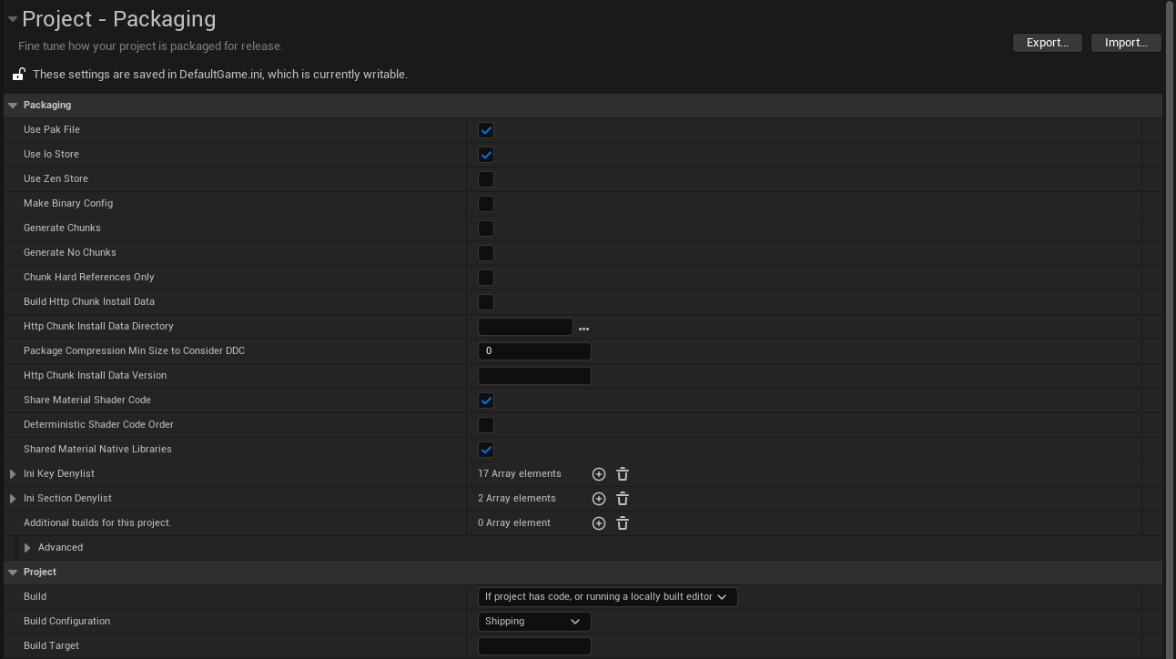

# Casting headset POV to another screen

<https://www.oculus.com/casting/>

Log into Meta account on this website:

Navigate to the camera on the headset and press casting

Now you can view the video feed from the perspective of the user

# Unreal Engine 5 Development Notes

* For collision of the maze, we had to learn how to enable Complex Collision under the “Collisions” section in the details tab of the maze. This automatically makes a more complex collision mesh for the maze, because by default it uses a simple collision box that encapsulates the entire maze in a way that doesn’t allow the ball to actually be “inside” the maze.

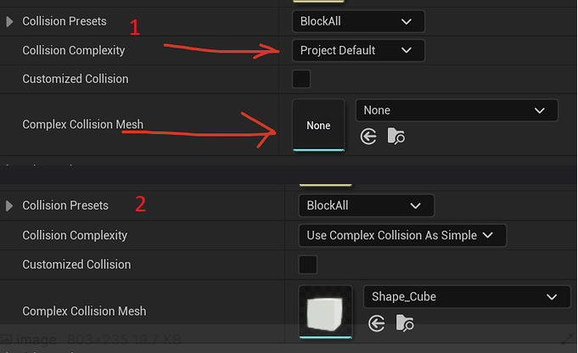

Set “Collision Complexity” to “Use Complex Collision As Simple” and set “Complex Collision Mesh” as the mesh you are making collision for.

* To have each level disappear, we had a “goal location” which when the ball collides with it, it’ll cause the maze to disappear and would make another one appear.